**Student Name:** **Weight: ________%**

**Student ID:** **Marks: __________**

Lab 3: Advanced Routing Protocols

**TASK 1: CONFIGURING DNS**

Please attach screenshots for each step. (5 points)

The bottom left-hand corner of the screen displays the icons that represent device categories or groups, such as Routers, Switches, or End Devices. Moving the cursor over the device categories will display each individual device category. To select a device, first select the device category and then select the device that is required.

a. Select **End Devices** from the options in the bottom left-hand corner. Drag and drop one **Generic PCs** onto your design area.

b. Select **Switches** from the options in the bottom left-hand corner. Add a **2950-24** switch to the design area.

c. Select **Connections** from the bottom left-hand corner and choose Copper Straight-through to connect the devices as per below.

1. PC0 connects to Fast Ethernet 0/1 on Switch0

2. Switch0 connects to Fast Ethernet 0/2 on Server1

d. Select **End Devices** from the options in the bottom left-hand corner. Drag and drop one **Serve**r onto your design area.

## Step 2: Configure network devices

a. Select **PC0** and choose the **Desktop** tab.

b. Select **IP Configuration**.

c. Set the **IP Address, Subnet Mask**, and **Default Gateway** using information from the table shown below.

d. Repeat steps a – c for Server1.

|  |  |  |  |  |
| --- | --- | --- | --- | --- |
| **Device** | **IP Address** | **Subnet Mask** | **Default Gateway** | **DNS Server** |
| PC0 | 192.168.1.10 | 255.255.255.0 | Leave Blank | 192.168.1.1 |
| Server0 | 192.168.1.1 | 255.255.255.0 | Leave Blank | 192.168.1.1 |

## Step 3: Configure DNS on Server1

1. Select **Server0** and choose the **Services** tab.
2. Select **DNS** under services on the left-hand column**.**
3. For **DNS Service** select **On**
4. For **Resource Records** type www.mypage.com in the **Name** box. Leave the **Type** as **A Record**.
5. In the **Address bar** add 192.168.1.1
6. Select **ADD** – this will add www.mypage.com as a static DNS at position 0.

**TASK 2: RIP (5 points)**

Please attach screenshots for each step(one per each process).

Build the following topology:

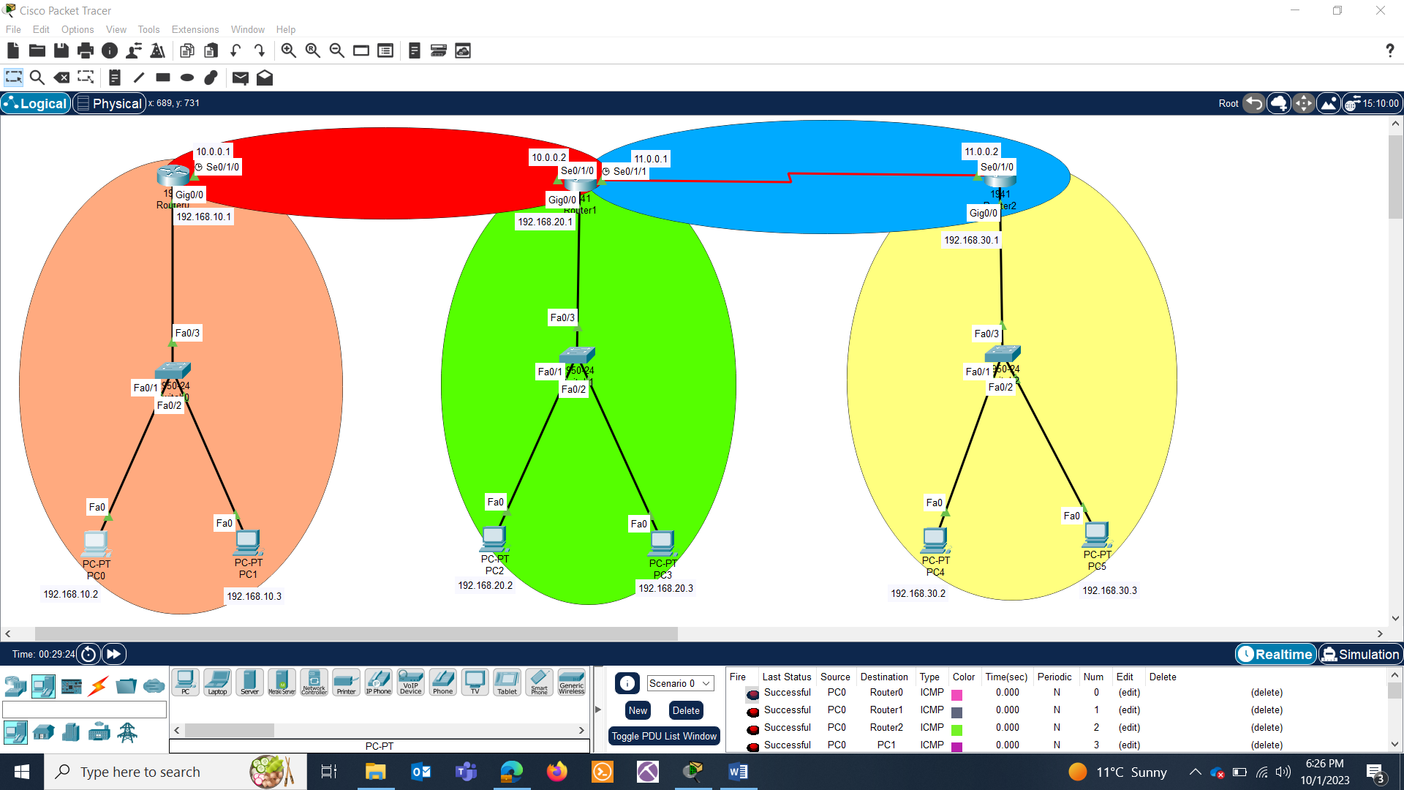

PC CONFIGURATIONS:

|  |  |  |  |  |
| --- | --- | --- | --- | --- |
| S.NO | Device | IPv4 | Subnet mask | Default Gateway |
| 1 | PC0 | 192.168.10.2 | 24 | 192.168.10.1 |
| 2 | PC1 | 192.168.10.3 | 24 | 192.168.10.1 |
| 3 | PC2 | 192.168.20.2 | 24 | 192.168.20.1 |
| 4 | PC3 | 192.168.20.3 | 24 | 192.168.20.1 |
| 5 | PC4 | 192.168.30.2 | 24 | 192.168.30.1 |
| 6 | PC5 | 192.168.30.3 | 24 | 192.168.30.1 |

ROUTERS CONFIGURATION:

|  |  |  |  |  |
| --- | --- | --- | --- | --- |
| S.NO | Device | Interface | IPv4 address | Subnet mask |
| 1 | Router0 | Gig0/0 | 192.168.10.1 | 24 |
| Se0/1/0 | 10.0.0.1 | 8 |
| 2 | Router1 | Gig0/0 | 192.168.20.1 | 24 |
| Se0/1/0 | 10.0.0.2 | 8 |
| Se0/1/1 | 11.0.0.1 | 8 |
| 3 | Router2 | Gig0/0 | 192.168.30.1 | 24 |
| Se0/1/0 | 11.0.0.2 | 8 |

PINGING BTW DIFFERENT NETWORKS:

Answer the following: {Attach screenshots)

* Ping from PC0 to PC1, PC2, PC3, PC4 & PC5.
* Are you able to ping ?
* Why or if not why so ?

BUILDING ROUTES BETWEEN NETWORKS:

* Kindly configure rip routes in Router0, Router1 & Router2. Attach screenshot for each.
* Attach the screenshots of the routes with the command : sh ip route.

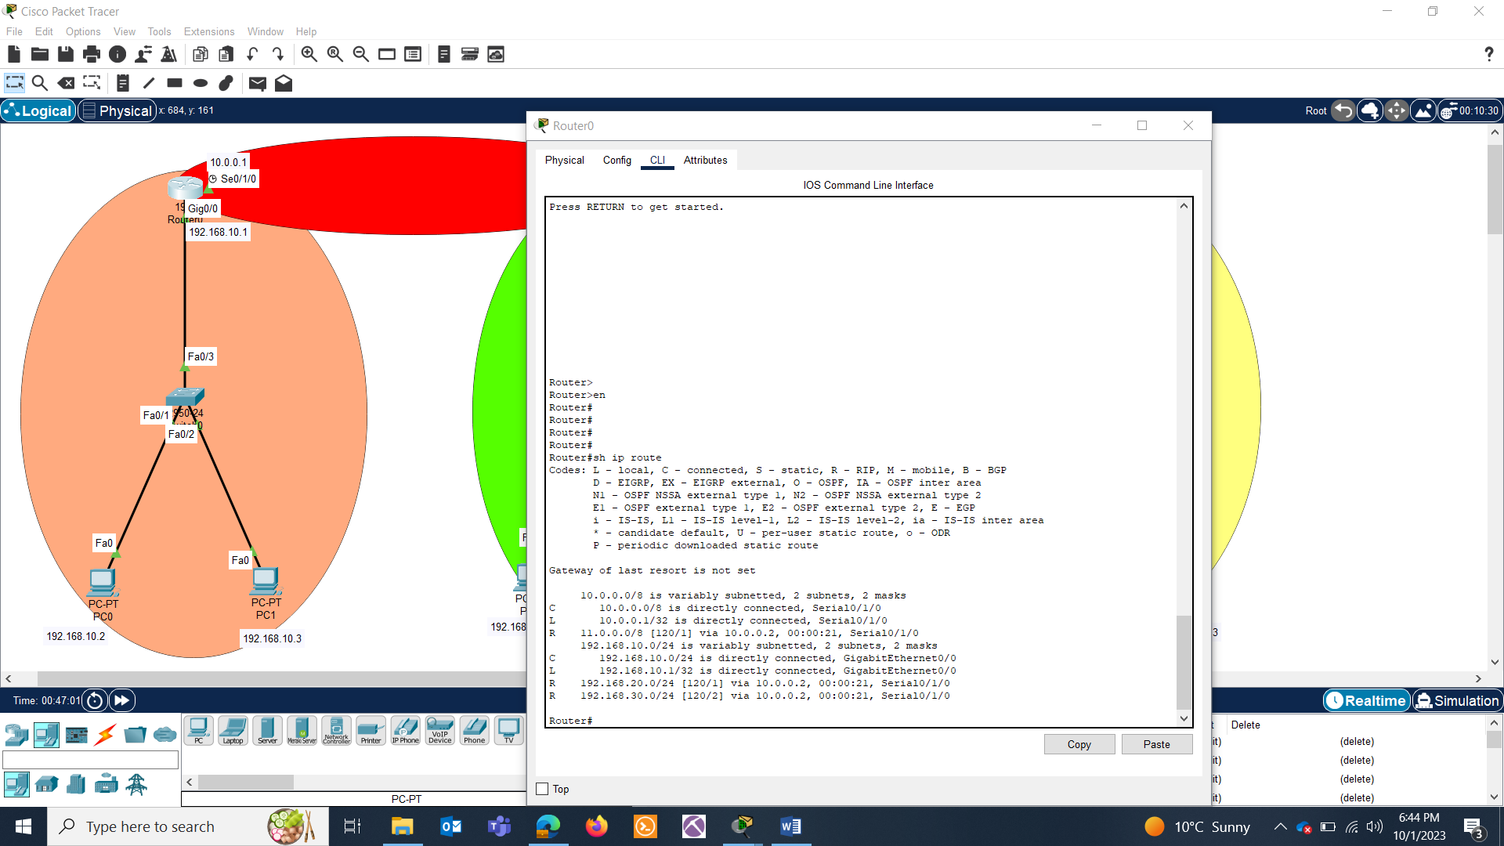

PING TEST BTW DIFFERENT NETWORKS:

* Ping from PC0 to PC1, PC2, PC3, PC4 & PC5.
* Attach the screenshot:

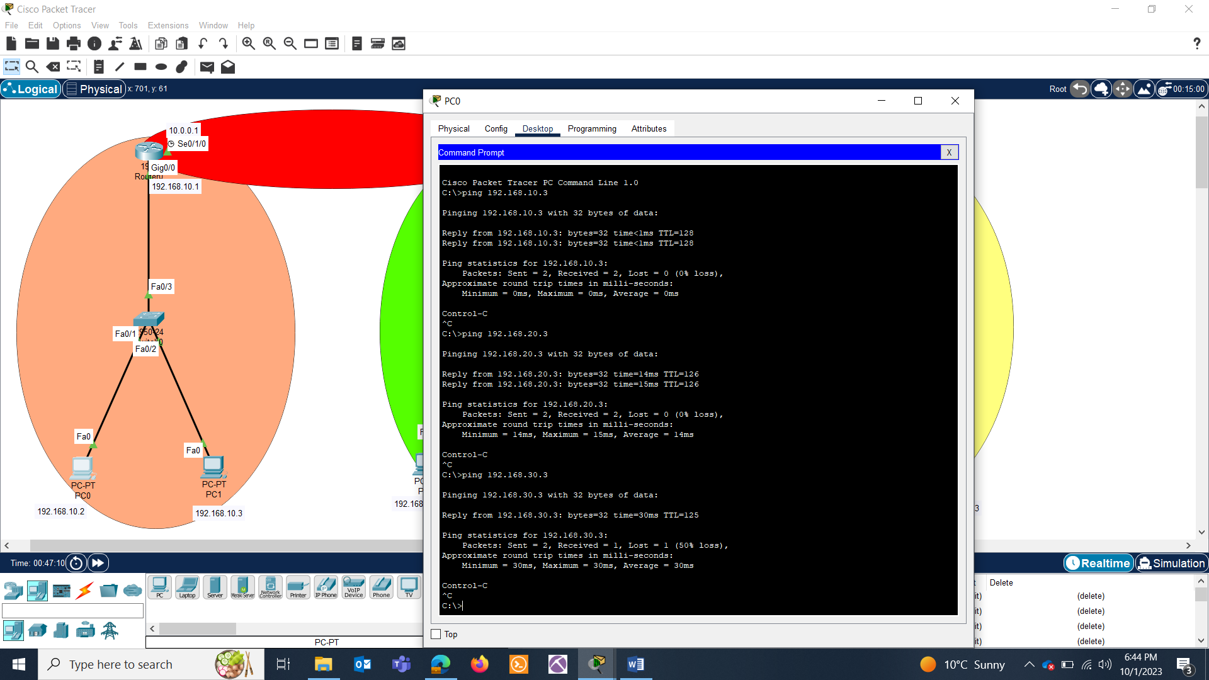

**TASK 3: OSPF 5 points**

Create the following topology :

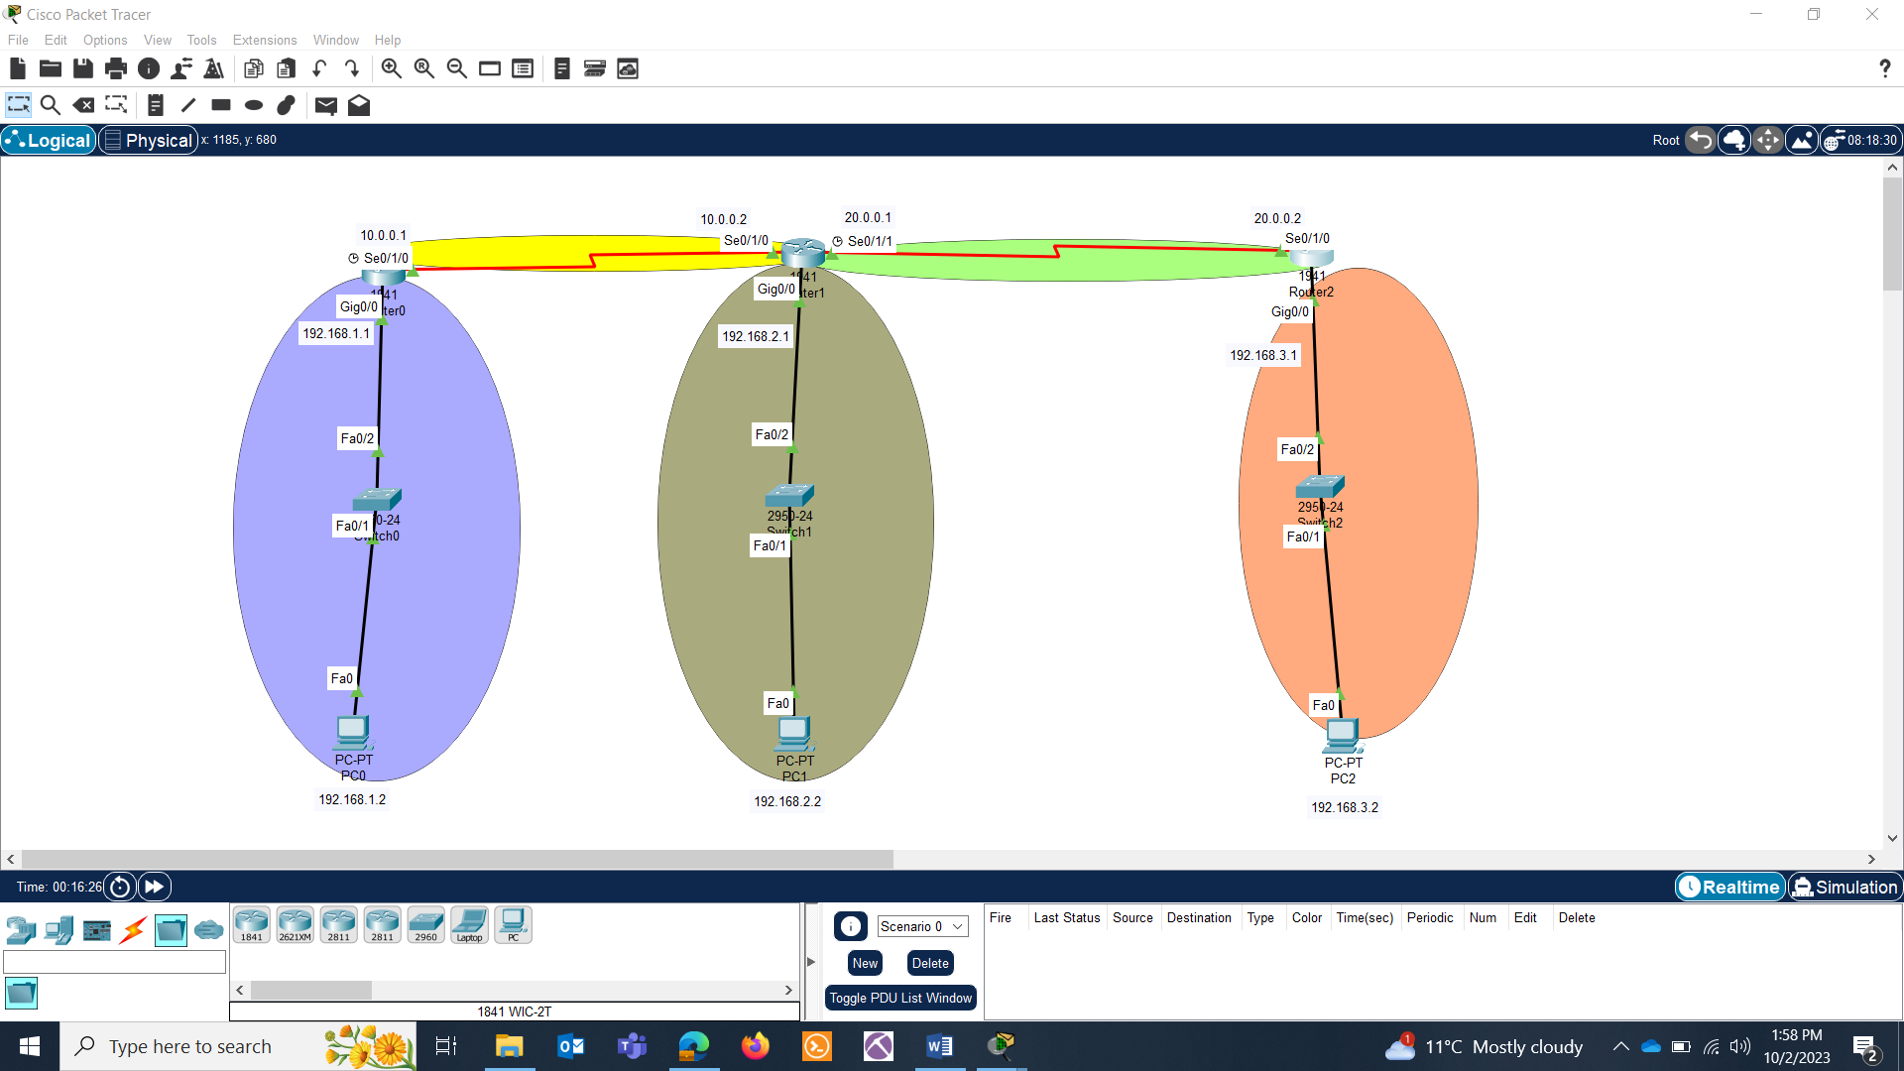

PC CONFIGURATIONS:

|  |  |  |  |  |
| --- | --- | --- | --- | --- |
| S.NO | Device | IPv4 | Subnet mask | Default Gateway |
| 1 | PC0 | 192.168.1.2 | 24 | 192.168.1.1 |
| 2 | PC1 | 192.168.2.2 | 24 | 192.168.2.1 |
| 3 | PC2 | 192.168.3.2 | 24 | 192.168.3.1 |

ROUTERS CONFIGURATIONS:

|  |  |  |  |  |
| --- | --- | --- | --- | --- |
| S.NO | Device | Interface | IPv4 address | Subnet mask |
| 1 | Router0 | Gig0/0 | 192.168.1.1 | 24 |
| Se0/1/0 | 10.0.0.1 | 8 |
| 2 | Router1 | Gig0/0 | 192.168.2.1 | 24 |
| Se0/1/0 | 10.0.0.2 | 8 |
| Se0/1/1 | 20.0.0.1 | 8 |
| 3 | Router2 | Gig0/0 | 192.168.3.1 | 24 |
| Se0/1/0 | 20.0.0.2 | 8 |

* Enable OSPF Routing on Cisco Routers. Attach screenshots for each router.
* Show ip route for each router.
* For each router, execute the following commands and attach screenshot:
  + show ip ospf database
  + show ip ospf interface
  + show ip ospf database router

**TASK 4: BGP (5 points)**

Create this topology:

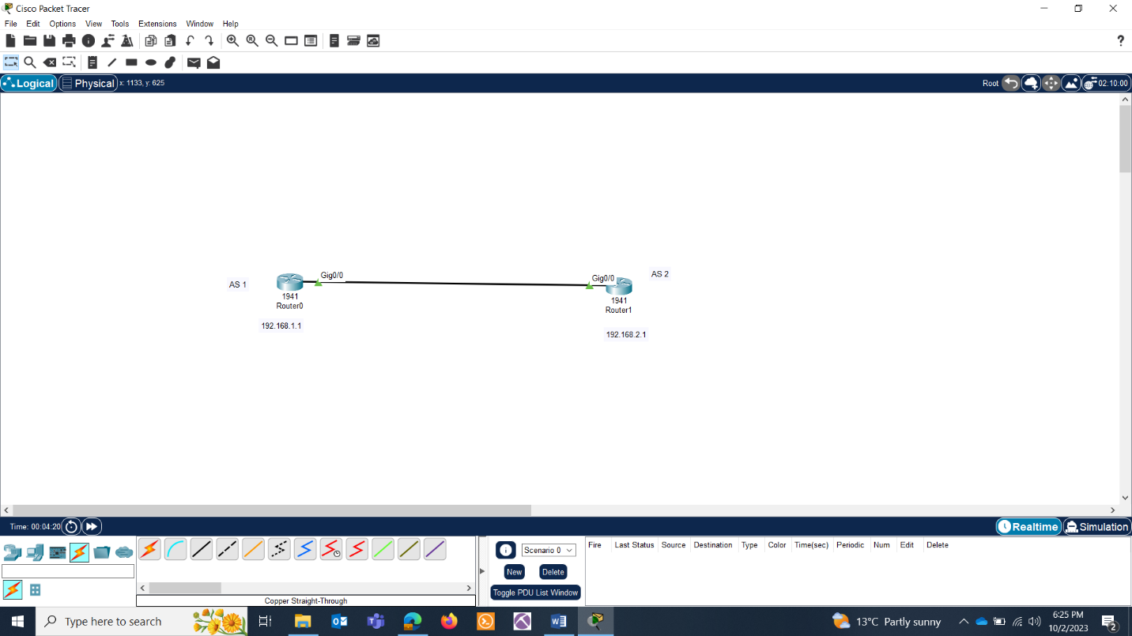

Paste the screenshots of the following:

* What is an AS ?
* Configure BGP on both the router and attach screenshots.